**Lab 5:** JMP instructions

**Goals:**

1. How to draw QQ plots
2. How to store residuals from an analysis, then draw a QQ plot

There are two ways to draw QQ plots to assess normality in JMP. The first draws a separate QQ plot for each group of observations. The second saves the residuals then draws a QQ plot of the residuals.

We will use the hamburger data to demonstrate this.

**Separate plots for each group:**

Load the hamburger data file (see lab 4) and start the Fit Y by X dialog (see lab 3 or lab 4 for more info).

Click the red triangle by Oneway Analysis of cfu by treatment and select Normal Quantile Plot (first item in the second box of options). You can do this either before or after running the t-test. You will see something like:

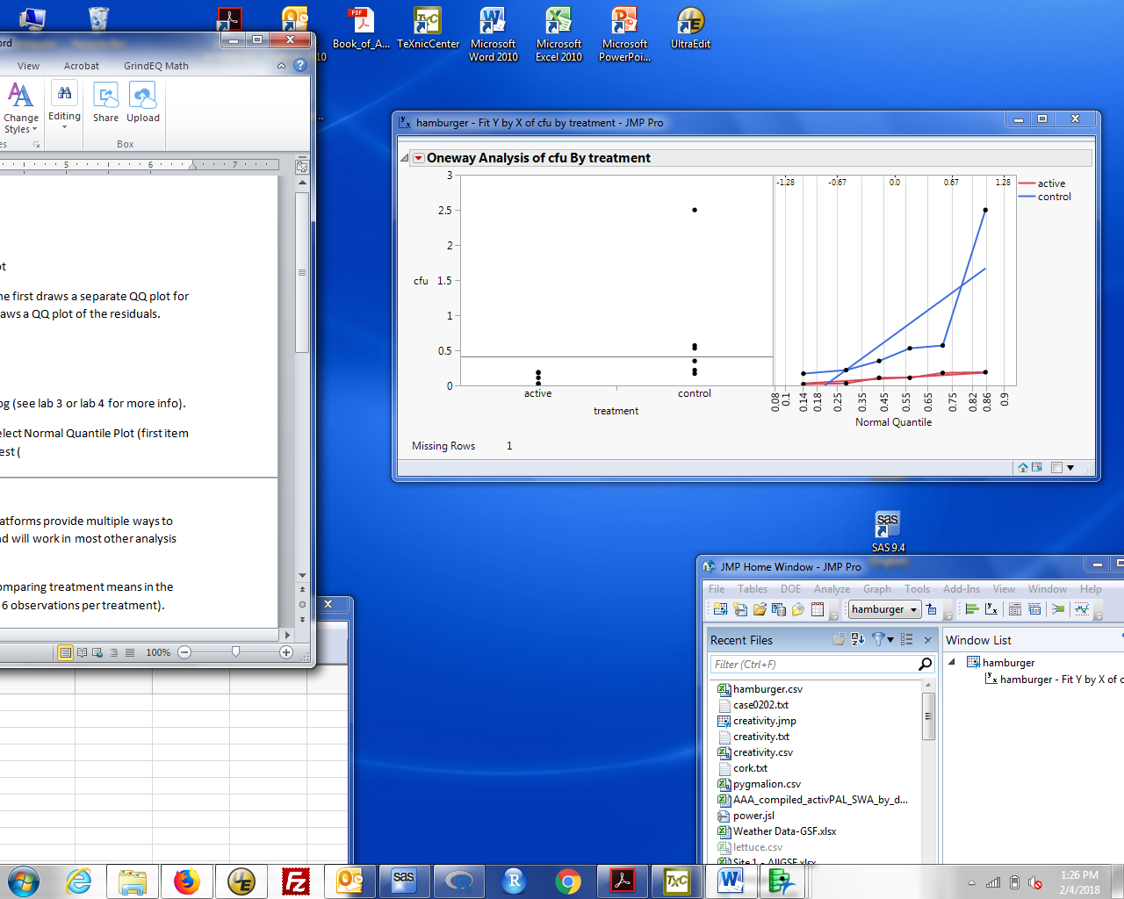

The plot on the right is added to the dot plot of the data. This shows a QQ plot for each group separately. The jagged lines with dots are the QQ plot of the data. The straight lines are what is expected if the observations followed a normal distribution. The red data (active) fits a normal; the blue data (control) do not.

This is a QQ plot of the observations. When draw separately for each group, it is the same as a QQ plot of the residuals. That is because within each group, the residuals are just a shifted version of the data values. As discussed in lecture, this is only true when you look at each group separately. When you look at both groups together, the properties of the residuals are no longer the same as those of the observations.

To look at residuals for all observations as one QQ plot, you need to store the residuals. The Fit Y by X dialog allows you to do this.

**Calculating and storing residuals:**

Some details depend on the analysis you’re doing. Some analysis platforms provide multiple ways to extract and manipulate residuals. Here’s what works in Fit Y by X and will work in most other analysis procedures.

Run the desired analysis, for example use Fit Y by X followed by Means/ANOVA/Pooled t to get a t-test. After you get the analysis, click the red triangle by ‘Oneway analysis …’. Select Save / Save Residuals. A column is added to the data table. That column has the residuals. If you use Save / Save Predicted, you get a column with the predicted values. These can be used for any subsequent plot or analysis.

To get a QQ plot from a column of residuals:

Select the data frame. You should have created a new column with the residuals. For the hamburger analysis, this will be labelled **cfu centered by treatment**. Select Analyze / Distribution and put the residual column into the Y box, and click OK. You should recognize this results box from lab 1 when we calculated descriptive statistics.

Click the red triangle by cfu centered on treatment and select normal quantile plot. A new plot will appear next to the vertical histogram and box plot. Here's what it should look like:

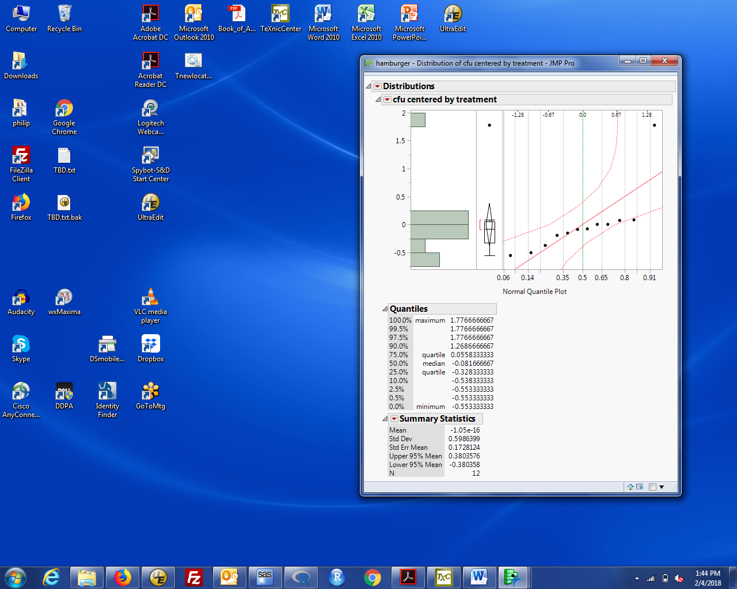

The dots are the observations and the solid straight line is what you would expect if the data were normal. The dashed curved lines are uncertainty bounds that depend on the sample size. If the observations are normal, you expect almost all the points to fall inside these bounds. I don't use these bounds because they are very conservative. Notice that these data, with a clear outlier, still appear normal (by the all points within the bounds criterion).

If you want to get rid of the box plot and vertical histogram (so you only have the QQ plot), click the red triangle by cfu centered by treatment and:

click Outlier Box Plot to uncheck it

select Histogram Options and click Histogram to uncheck it.

Now you just have the QQ plot.

Remember, you can copy the plot to your HW answers either by copying (ctrl-C) the entire Distributions window, pasting into a Word document then deleting unwanted text, or by saving the results in the Journal (ctrl-J) then saving the Journal as a .rtf or .doc file.